Key Measurements to Help You Design Your Kitchen

Get the ideal kitchen setup by understanding spatial relationships, dimensions and work zones

[http://st.houzz.com/simgs/5b63eb0d01368a0d_0-2278/stevenrandel.jpg](http://www.houzz.com/pro/stevenrandel/steven-corley-randel-architect)

[**Steven Randel**](http://www.houzz.com/user/stevenrandel)

Houzz Contributor. Steven Corley Randel has practiced architecture in California... [More](javascript:;)

[Comment67](http://www.houzz.com/ideabooks/25228528?utm_source=Houzz&utm_campaign=u470&utm_medium=email&utm_content=gallery3#addComment)[Bookmark2,425Like123EmbedPrint](javascript:;)

Click "Embed" to display an article on your own website or blog.

Whether you are moving into an existing kitchen, remodeling the one you have or building a new one, understanding a few key measurements and organizational guidelines can help your culinary life run more smoothly.   
  
Kitchens provide storage for your food and cookware, give you room for prep and cleanup, and of course also provide a place where you can cook and bake. When it’s thoughtfully arranged, these functions operate logically, making work in your kitchen a better experience. Here’s how to get the ideal setup.

[[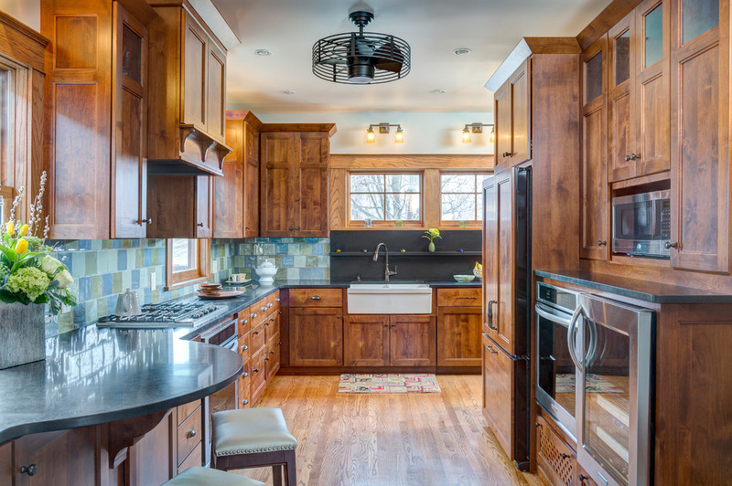](http://www.houzz.com/photos/10272790/Hyde-Park-Return-to-Prairie-craftsman-kitchen-kansas-city)](http://www.houzz.com/photos/10272790/Hyde-Park-Return-to-Prairie-craftsman-kitchen-kansas-city)

[**Orion Design, Inc.**](http://www.houzz.com/pro/oriondesign/orion-design-inc)

[**Save to Ideabook**](javascript:;)

[**Email Photo**](javascript:;)

Ideally, refrigeration and dry-goods storage should be located nearest to the kitchen’s entry point. The cooking area should be located toward the dining spaces, and the sink is best positioned between those two functions. This creates what’s called a [work triangle](http://www.houzz.com/ideabooks/1042314/list/How-to-Set-Up-a-Kitchen-Work-Triangle). The best work triangle is less than 21 linear feet (6.4 meters). Work triangles that exceed 26 feet (7.9 meters) make moving from one function to another inefficient in most cases.

[[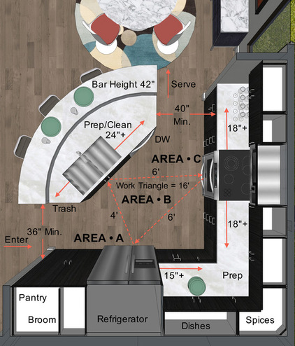](http://www.houzz.com/photos/10318560/Kitchen-Diagram-contemporary-floor-plan-los-angeles)](http://www.houzz.com/photos/10318560/Kitchen-Diagram-contemporary-floor-plan-los-angeles)

[**Steven Corley Randel, Architect**](http://www.houzz.com/pro/stevenrandel/steven-corley-randel-architect)

[**Save to Ideabook**](javascript:;)

[**Email Photo**](javascript:;)

This cutaway plan illustrates arrangements and dimensions for a modest-size kitchen. Note that the preparation area is split between the island with the sink and the corner of the kitchen. The work triangle is compact. There will always be a few tradeoffs in any space.   
  
Let’s take a look at the three main functions of a kitchen:  
  
1. Storage  
2. Preparation  
3. Cooking  
  
Everyone has personal preferences for what works best, so consider this a guide and not a rulebook.

[[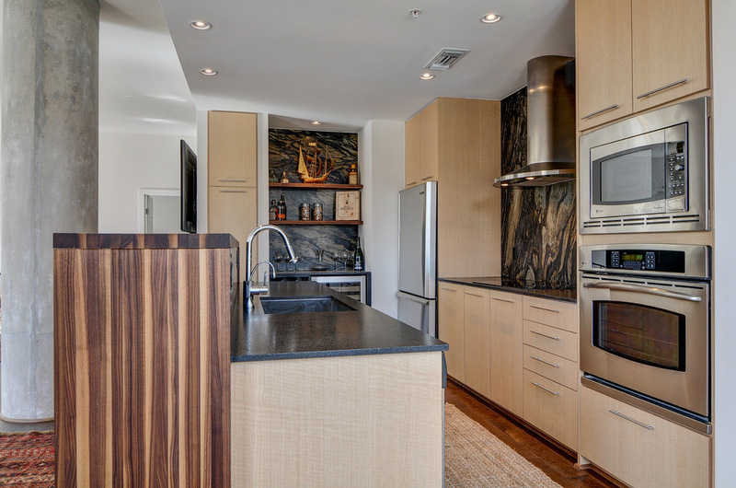](http://www.houzz.com/photos/10231034/Shylo-s-N--Houston-contemporary-kitchen-dallas)](http://www.houzz.com/photos/10231034/Shylo-s-N--Houston-contemporary-kitchen-dallas)

[**The Kitchen Source**](http://www.houzz.com/pro/thekitchensource/the-kitchen-source)

[**Save to Ideabook**](javascript:;)

[**Email Photo**](javascript:;)

**Storage.**As noted, designers recommend putting refrigeration and dry-goods storage at the kitchen entry point. Putting your pantry on one side and a countertop that’s 15 to 24 inches (38 to 61 centimeters) on the other is a good idea. This will allow you to easily set down items that have been taken out of the freezer and refrigerator.  
  
The pantry can hold dry goods plus brooms and supplies like paper towels. Use drawers in this area to hold plastic bags, foil and anything that can contain food to be stored. For the cabinets in this area, you will want to have mixing bowls, cake pans, measuring utensils and any other items that aid in assembling meals.  
  
[See more on kitchen storage planning](http://www.houzz.com/ideabooks/5742976/list/How-to-Plan-Your-Kitchen-Storage-for-Maximum-Efficiency)

[[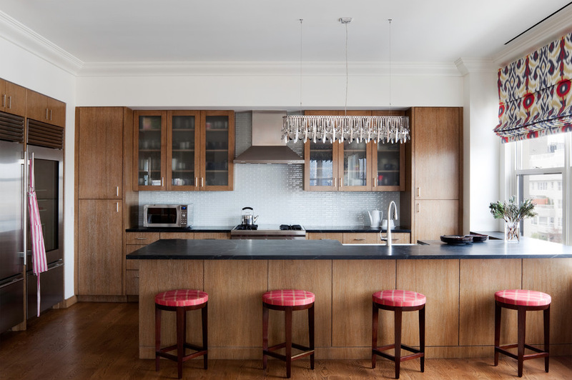](http://www.houzz.com/photos/9985328/Greenwich-Village-Apartment-contemporary-kitchen-new-york)](http://www.houzz.com/photos/9985328/Greenwich-Village-Apartment-contemporary-kitchen-new-york)

[**GSW Cabinetry Inc.**](http://www.houzz.com/pro/didgi/gsw-cabinetry-inc)

[**Save to Ideabook**](javascript:;)

[**Email Photo**](javascript:;)

**Preparation.**Ideally, prep and cleaning space is best locatedaround the sink.Within these areas will be everyday glasses and dishes, along with trash receptacles and the dishwasher. Allow 18 to 36 inches (45 to 92 centimeters) of countertop space on one or both sides of your sink.  
  
Preparation areas are best kept clear of other items, since you will always be taking out bowls, plates and utensils there. Allow at least 36 inches (92 centimeters) of uncluttered countertop space for preparation in a small kitchen. Larger kitchens will have much more. This is one reason that islands are so popular. They provide broad and well-lit surfaces on which to perform the majority of kitchen tasks.

[[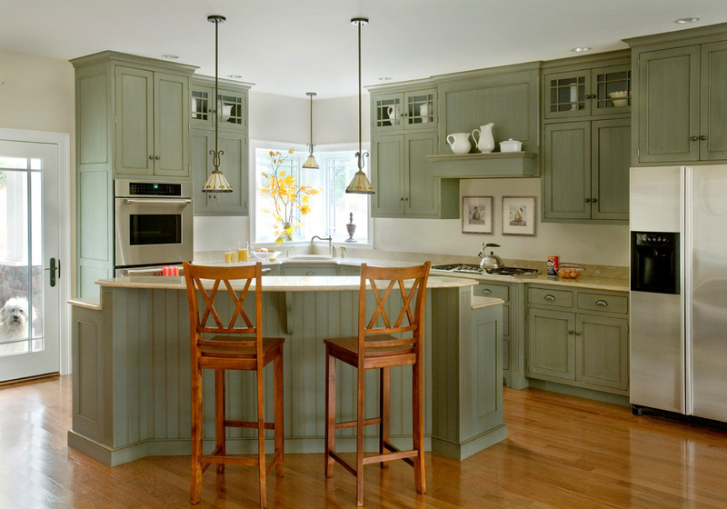](http://www.houzz.com/photos/10270693/Heartwood-Kitchens----2-traditional-kitchen-boston)](http://www.houzz.com/photos/10270693/Heartwood-Kitchens----2-traditional-kitchen-boston)

[**Quality Custom Cabinetry, Inc**](http://www.houzz.com/pro/qcci/quality-custom-cabinetry-inc)

[**Save to Ideabook**](javascript:;)

[**Email Photo**](javascript:;)

**Cooking.**The cooking centers should be arranged around the range, cooktop and wall ovens.Place pots, frying pans and baking sheets in the vicinity around your burners and ovens. It is a good idea to place small appliances such as toasters and coffeemakers in this area also, as it will leave your preparation areas unobstructed.  
  
Allow 21 to 36 inches (53 to 92 centimeters) of countertop on either side of your cooktop. If possible, place wall ovens with a free countertop immediately next to them so that you can set down hot food immediately. Place seasonings, breadboards and potholders in nearby drawers and cupboards. Keep serveware toward the dining area.

[[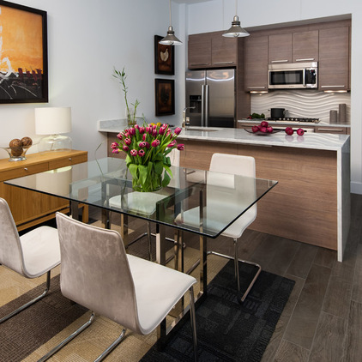](http://www.houzz.com/photos/10232432/Condo--Washington-DC-contemporary-kitchen-dc-metro)](http://www.houzz.com/photos/10232432/Condo--Washington-DC-contemporary-kitchen-dc-metro)

[**Joanna Starosta, Porcelanosa**](http://www.houzz.com/pro/jrstar/joanna-starosta-porcelanosa)

[**Save to Ideabook**](javascript:;)

[**Email Photo**](javascript:;)

**Recommended Dimensions of Kitchen Elements**  
  
The dimensions of all the pieces in your kitchen are important to get right to make the best use of your space. A common refrigerator width is slightly less than 36 inches (92 centimeters). The problem is often the depth. In recent years some manufacturers have designed them to be much deeper than a 24-inch (61-centimeter) base cabinet. You can still buy shallower freestanding refrigerators, but you have to pay close attention to the dimensions listed in its specifications to be certain. The other option is built-in configurations, but they are significantly more expensive.   
  
Look for a depth of 30 inches (76 centimeters) or less, excluding handles, unless you can design your kitchen space to accept a deeper unit. Another thing to consider is the swing of the refrigerator door. Always examine the swing direction to see if it will meet an obstruction.  
  
[See more on planning for a built-in refrigerator](http://www.houzz.com/ideabooks/12545103/list/Get-the-Look-of-a-Built-in-Fridge-for-Less)

[[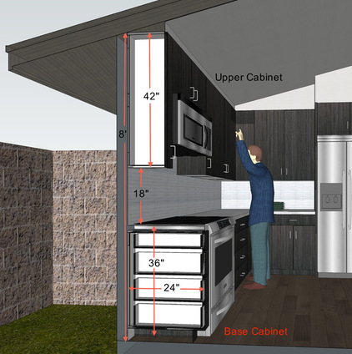](http://www.houzz.com/photos/10318608/Cabinet-Cross-Section-contemporary-section-los-angeles)](http://www.houzz.com/photos/10318608/Cabinet-Cross-Section-contemporary-section-los-angeles)

[**Steven Corley Randel, Architect**](http://www.houzz.com/pro/stevenrandel/steven-corley-randel-architect)

[**Save to Ideabook**](javascript:;)

[**Email Photo**](javascript:;)

Here you can see how the height of the cabinets plays an important part in the configuration. Upper cabinets are normally positioned at 18 inches (46 centimeters) above the countertop and are 30 to 42 inches (76 to 107 centimeters) in height. Consider that your average maximum reach over and into an upper cabinet is 70 to 80 inches (178 to 203 centimeters) above the floor. Cabinets set at above 7 feet will likely need to be accessed with a step ladder. Cabinets above 8 feet are not practical for the majority of people; however, they may serve as storage for seasonal or decorative items, to be reached with step stools and ladders.   
  
The standard dimensions for base cabinets are 24 inches (61 centimeters) deep and 36 inches (92 centimeters) high. In general people are getting taller, so some homeowners are bumping up the counter height to 38 inches (97 centimeters).

[[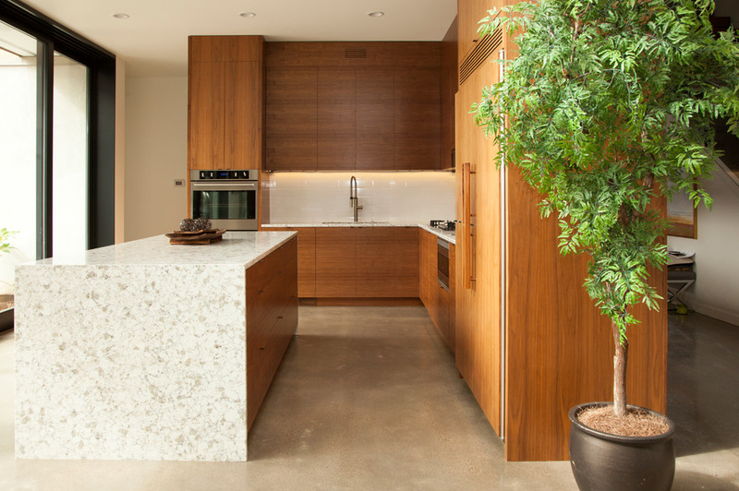](http://www.houzz.com/photos/9954342/Eric-modern-kitchen-portland)](http://www.houzz.com/photos/9954342/Eric-modern-kitchen-portland)

[**Whitney Lyons**](http://www.houzz.com/pro/whitneylyons/whitney-lyons)

[**Save to Ideabook**](javascript:;)

[**Email Photo**](javascript:;)

Another important dimension to consider is the distance between cabinets. Entry points can be as little as 36 inches (92 centimeters) when there is a cabinet on only one side. Stay at least 42 inches (107 centimeters) from the face of a cabinet to the one on the other side; 48 inches (122 centimeters) is even better, but going beyond 60 inches (152 centimeters) is too wide in most cases. However, if it is a U-shaped kitchen, you could get away with up to 96 inches (244 centimeters).  
  
**Houzz Guide:** [How to Remodel Your Kitchen](http://www.houzz.com/ideabooks/1198907/list/Homeowner-s-Workbook--How-to-Remodel-Your-Kitchen)